List View :

Langsung aja ga ada banner,

Judul List ( Article / Video ) ( Video Material List / Written Article List )

\*\* List Video : ( Kurang lebih kayak youtube lah

How to count from 1 to 10 ( Judul

By : Nathaniel Davin

6/10/2021

How to count from 1 to 10 ( Judul

By : Nathaniel Davin

6/10/2021

\*\* List Article :

Nama Artikel apa

Author

Tanggal Rilis

Materi terkait apa : Programming Logic

Hashtag / Genre ( contoh : Computer Science, Programming, Java, Tutorial )

< Thumbnail

* Contoh kasar ada di bawah, coba cek

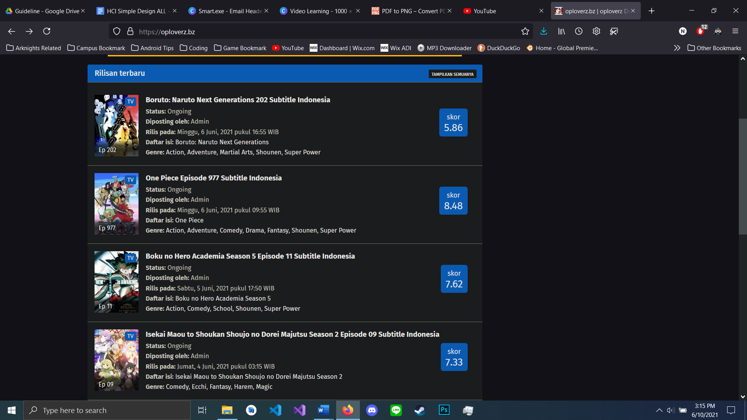

^ Contoh kasar